# Homework 2

a. **Decision Variables** –

1.Flow from Node 1 to Node 2 - X12

2.Flow from Node 1 to Node 3 - X13

3.Flow from Node 1 to Node 4 - X14

4.Flow from Node 2 to Node 4 - X24

5.Flow from Node 2 to Node 5 - X25

6.Flow from Node 4 to Node 3 - X43

7.Flow from Node 4 to Node 5 - X45

8.Flow from Node 3 to Node 5 - X35

**Objective Function** - Maximize f (flow from 1 to 5)

**Constraints**-

|  |  |
| --- | --- |
| **Constraint** | **Constraint Equations** |
| Flow Constraint at Node 1 | -X12-X13-X14 = -f |
| Flow Constraint at Node 2 | X12 = X24+X25 |
| Flow Constraint at Node 3 | X13+X43 = X35 |
| Flow Constraint at Node 4 | X14+X24= X43+X45 |
| Flow Constraint at Node 5 | X25+X35+X45 = f |
| Capacity Constraint for X12 | 0<=X12 <= 5 |
| Capacity Constraint for X13 | 0<=X13 <= 2 |
| Capacity Constraint for X14 | 0<=X14 <= 1 |
| Capacity Constraint for X24 | 0<=X24 <= 3 |
| Capacity Constraint for X25 | 0<=X25 <= 1 |
| Capacity Constraint for X43 | 0<=X43 <= 1 |
| Capacity Constraint for X45 | 0<=X45 <= 4 |
| Capacity Constraint for X35 | 0<=X35 <= 7 |

b.

We will need decision variables for each node and for each edge.

**Decision Variables** –

1.Edge between 1 and 2 - Z12

2. Edge between 1 and 3- Z13

3. Edge between 1 and 4- Z14

4. Edge between 2 and 4 - Z24

5. Edge between 2 and 5 - Z25

6. Edge between 4 and 3- Z43

7. Edge between 4 and 5 - Z45

8. Edge between 3 and 5 - Z35

9. Node 1 - Y1

10. Node 2- Y2

11. Node 3 – Y3

12. Node 4 – Y4

13. Node 5 – Y5

All edge variables (Zij >= 0 where i and j represent nodes) and all node variables Yi (where i belongs to (2,4)) are unrestricted

**Objective Function** – Minimize 5*Z12 + 2*Z13 + 1*Z14 +3*Z24 + 1*Z25 + 1*Z43 + 4*Z45 +7*Z35

**Constraints** –

|  |  |
| --- | --- |
| **Constraint** | **Constraint Equations** |
| Constraint 1 | Y1 -Y5 >= 1 |
| Constraint 2 | Y2, Y3, Y4 unrestricted |
| Constraint 3 | Z12 > = Y1 -Y2, Z12 > =0 |
| Constraint 4 | Z13 >= Y1 – Y3, Z13 >=0 |
| Constraint 5 | Z14 >= Y1 – Y4, Z14 >=0 |
| Constraint 6 | Z24 >= Y2 – Y4, Z24 >=0 |
| Constraint 7 | Z25 >= Y2 – Y5, Z25 >=0 |
| Constraint 8 | Z43 >= Y4 – Y3, Z43 >=0 |
| Constraint 9 | Z45 >= Y4 – Y5, Z45 >=0 |
| Constraint 10 | Z35 >= Y3 – Y5, Z35 >=0 |

We get the following results after we solve this optimization problem in excel.

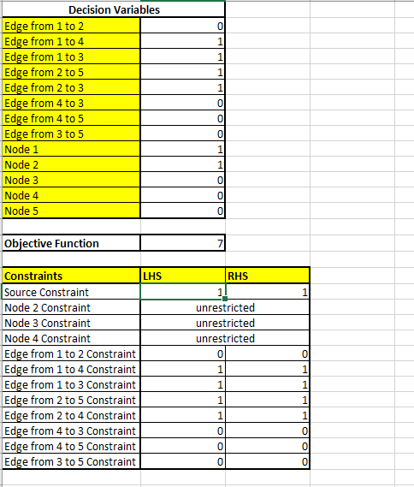

The optimal value is 7. This is an example of a strong duality problem since both the problems are feasible. And hence there is one optimal solution which is same for the both the primal and dual.

If we solved the maximum flow problem, it would have yielded the same answer.

c. The maximum flow minimum cut theorem states that the value of the maximum flow is lesser than or equal to the sum of the edges of the minimum cut.

Reason –

For every edge the flow is lesser than or equal to the capacity of the edge. Hence, for a cut, the total flow across the edges will always be less/equal than the sum of the capacities of the edges.

A minimum cut will consist of edges which have least capacities. Additionally, the flow through is a network is generally restricted by these least capacity edges. And hence intuitively for the maximum flow, even if there are edges with higher capacities, they will not be utilized to their fullest.

d. By inspection, the minimum cut is the one that goes through the edges -Z13, Z14, Z24, Z25.

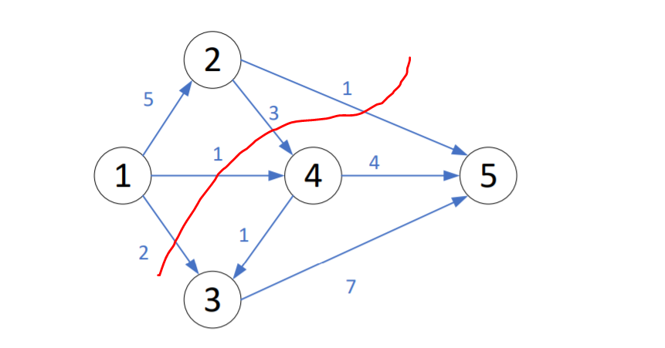

The capacity of this cut is 7 (2+1+3+1).

We look at the shadow price analysis of the primal problem given below-

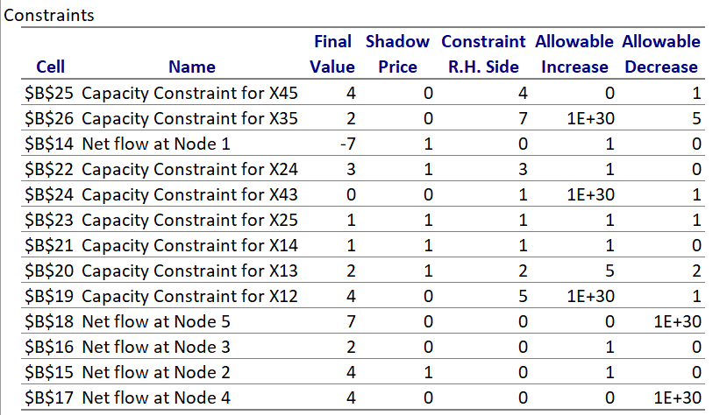

From the above table, we can deduce that the shadow prices for the edges between (1,4), (1,3), (2,4), (2,5) and the shadow prices of Nodes 1 and 2 are 1 . This implies that if we increase the RHS of these constraints by 1, the objective function value increases by 1 unit. So these edges have full capacities in max-flow problem. And these in turn are the values for the dual problem constraints. Therefore to minimize the capacity of the cut, by max_flow/min_cut theorem, we know all other cuts’ capacities will be larger than this cut. So this is the min cut.